NAD Installation Manual

For Fire Alarm Installer/Service Agent

Presented by
Boyd Robinson
Alarm New Zealand
10 west Terrace
Newton
Auckland
Tel : (09) 3030303
Fax : (09) 3020324
Email: HelpDesk@alarmnz.com
Web: http://www.Alarmnz.com

Table of Contents

1. Introduction 4

2. Installation Kit Contents 4

3. Precautions 4

4. Mounting 4

5. Wiring 5

6. Pre-commissioning checks 6

7. Commisioning NAD 7

8. Alterations 7

9. Contact 7

Table of Figures

1. NAD Installation 9

2. NAD Internal Layout 10

3. NAD Internal Wiring 11

4. NAD ADSL Wiring 12

Appendix

1. NAD Commissioning check-list 13

Document History

Version | Status | Date | Comments
1 | Draft | 3rd May 2007 | First draft
1.1 | Update | 12th September 2007 | Second draft
1.2 | Update | 14th September 2007 | Third draft
1.3 | Update | 23th December 2008 | Testing/commissioning changes by Ben Wyness
1.4 | Update | 10 Feburary 2009 | Copy proof read and re-edited by N. Clifton

Introduction

The NAD (Network Access Device) is designed for connection to any Telco network for monitoring broadband private fire alarms, security systems reporting the status of these units to an ALARMSWITCH Concentrator (IP Alarm receiver). The NAD can be used to replace existing older redundant analogue network access devices used by other Automatic Alarm monitoring service providers.

The ALARMSWITCH Concentrator can monitor multiple IP Alarm systems via a single NAD connected to any Telco network including lift phones, building automation, security and HVAC. This document provides installation and commissioning information for a NAD in the context of a brigade connection of an Automatic Fire Alarm only.

NAD Contents

NAD cabinet comprising:

Power Supply Unit

Router/Switch/Modem

ALARMSERVER (includes two legacy SGD ports or 8x PFA’s )

Sealed Lead Acid battery (x2)

Installation manual

If the NAD is connected to the ADSL network the following is also included:

Wired ADSL splitter

Captive BT jack-point

Telsplice connectors

ADSL BT to RJ11 connection lead

Precautions

Observe Antistatic precautions.
Isolate cabinet power and remove battery before mounting.
Wear protective appropriate protective equipment while mounting cabinet

Mounting

Mount cabinet in clean dry area with adequate ventilation.
Ensure suitable fixings sufficiently rated for the cabinet weight (approx 7Kg) are used.

Ensure cabinet fixings attach to structural timber, concrete, or steel.

Wiring
Power

- Ensure 230Vac dedicated live power circuit is available for the NAD cabinet. DO NOT connect AC power to NAD until you are ready to commission the connection.

2. Install battery but DO NOT connect, again until you are ready to commission the
connection. ( Mark the battery with an installation date with an indelible marker)

ADSL NAD

- Install NAD adjacent to Telecom ADSL demarcation point or BT jack

- Replace the standard BT jack with the captive BT jack supplied in installation Kit.

3. Install the filter as per supplied ADSL wiring diagram and connect to the line or number specified on connection datasheet at Telecom Demarcation point. Ensure cable pair is terminated on pins 2 and 5 (center connector on each 3 way connector) of Krone terminals in captive BT socket.

WIRELESS 3G NAD

If possible check GSM/CDMA signal strength at proposed NAD location with a mobile. If insufficient signal is available relocate NAD to higher level in building away from steel and steel reinforced concrete structures if possible.

PFA-DBA /SGD’s

When ready, connect PFA-DBA/SGD’s RS485 data cable to NAD as per attached diagram. Connect each PFA-DBA/SGD individually and test correct signalling to Alarm New Zealand. Only connect additional PFA-DBA/SGD’s when correct signalling has been confirmed with Alarm New Zealand staff.

Pre-commissioning checks

SIGNALING

Contact Alarm New Zealand helpdesk. Ensure account is correctly “set up” and PFA number attached in ALARMSWITCH and NZFS STSMHS .Also check the connection to NZFS messaging is disabled.

POWER

Switch on AC power supply. Ensure green LED indicators on PSU are lit.

Check Power LED indicator on router is lit.

Check red LED on IP ALARM Communicator is flashing.

Ensure batteries are dated and initialled and connected, correctly observing polarity.

Switch off AC power supply and ensure battery backup is operational. Restore AC power supply.

NETWORK CONNECTIVITY

Check green link LED on IP ALARM Communicator is lit. If not lit check red (or grey) Ethernet cable is securely plugged into IP ALARM Communicator and into router and both devices have LED’s lit (indicating correct power) Yellow activity LED on IP ALARM Communicator will flash when data is being transferred.

Check signals are received at Alarm New Zealand within 5 minutes of applying power to NAD. If not connect laptop with Ethernet adapter (with WIN2000 OS or later Windows OS) to router with supplied yellow Ethernet cable and contact Alarm New Zealand HELPDESK.

PFA-DBA/SGD’s

Check connected alarm devices (e.g. SGD’s) are being polled (Poll lamp flashing).
If not please note number of SGD’s connected, type (multi-drop or non multi drop)address of SGD’s and which PFA or DBA they are connected to and contact Alarm New Zealand support.

Commissioning NAD

- Place PFA into “Isolate” mode. Call ALARM NZ and ensure signal is received by ALARMSWITCH.

- Instruct ALARM NZ staff to enable the PFA connection to signal to NZFS message handling system.

- If all tests are successful advise ALARM NZ commissioning has been completed.

Alterations

Contact Alarm New Zealand helpdesk before altering or connecting PFA-DBA/SGD’s.
Remove all power from the NAD. In the instance of an SGD exchange ensure replacement SGD’s are addressed identically and set to same mode (standard or multi-drop) as original SGD’s. If new SGD’s are to be installed arrange for ALARM NZ to program the ALARMIP Communicator to poll the new SGD’s. Once changes have been made and connections terminated and checked reconnect power and confirm correct operation of NAD and connected SGD’s.

Contact

All enquiries regarding connection and installation of this unit should be directed to: helpdesk@alarmnz.com, Phone 09 3030303

NAD –Common Configurations of FIRE Alarms

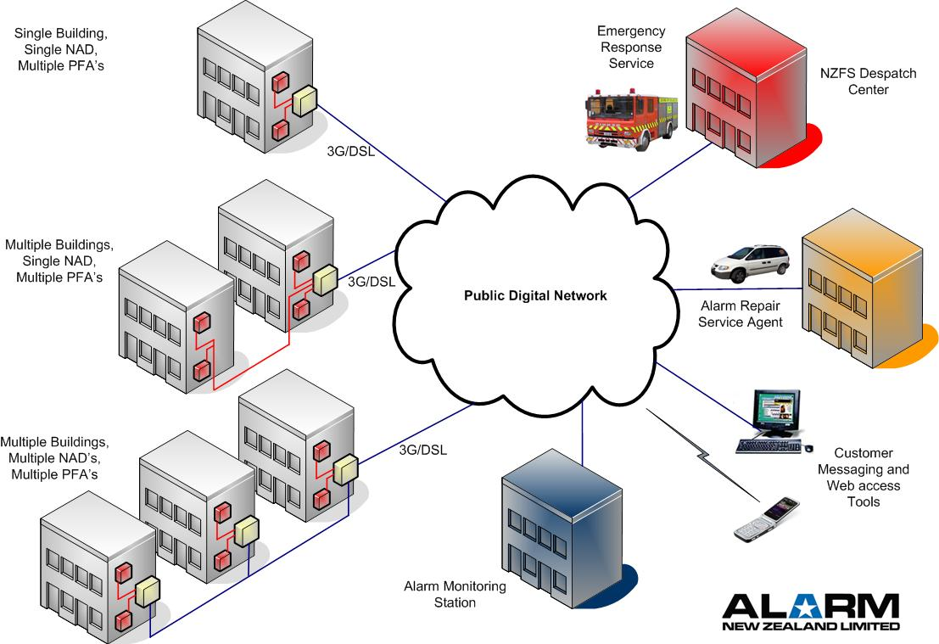

NAD INSTALLATION OPTIONS

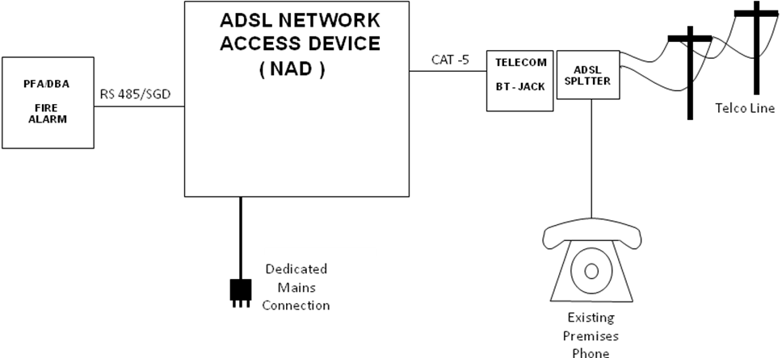

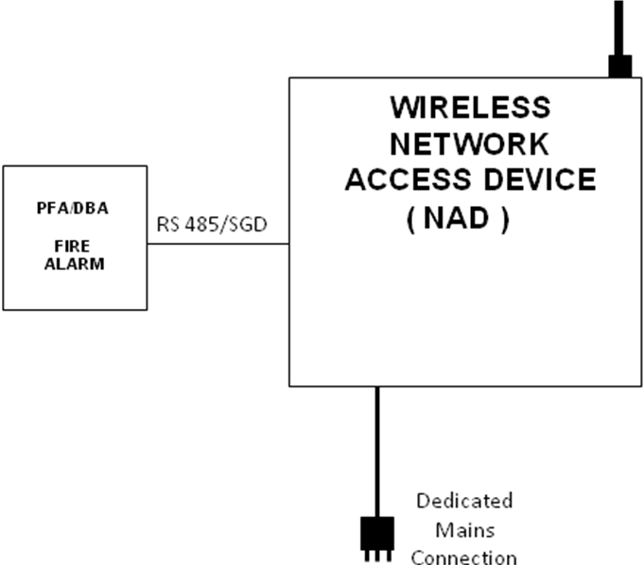

NAD INTERNAL LAYOUT OVERVIEW

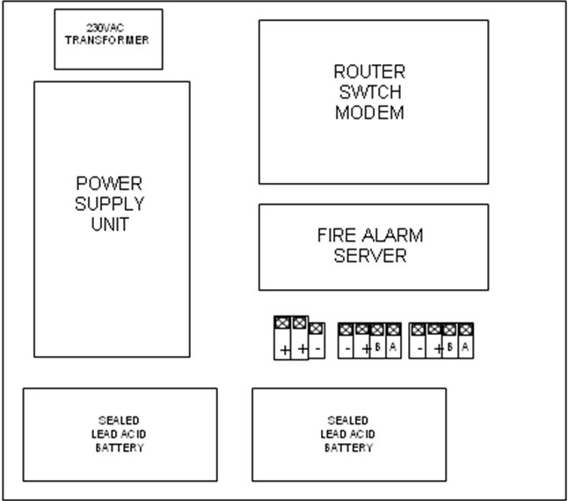

NAD –FIRE INTERNAL WIRING DIAGRAM

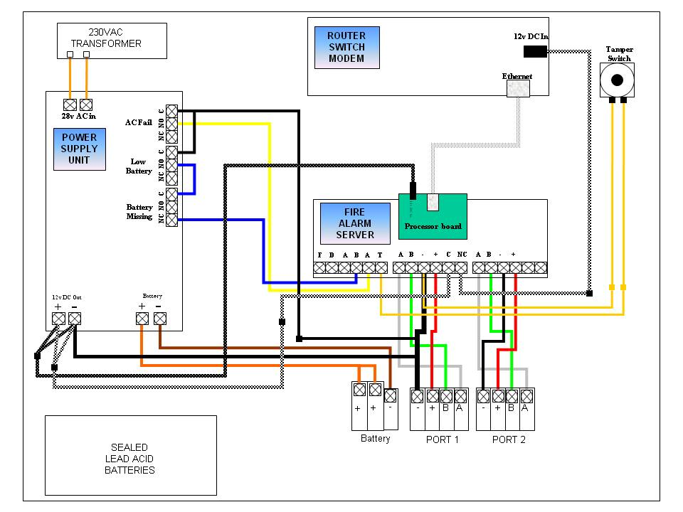

Note

Yellow or Grey Ethernet cable is spare and is only used for onsite diagnostic purposes.

NAD ADSL WIRING DIAGRAM

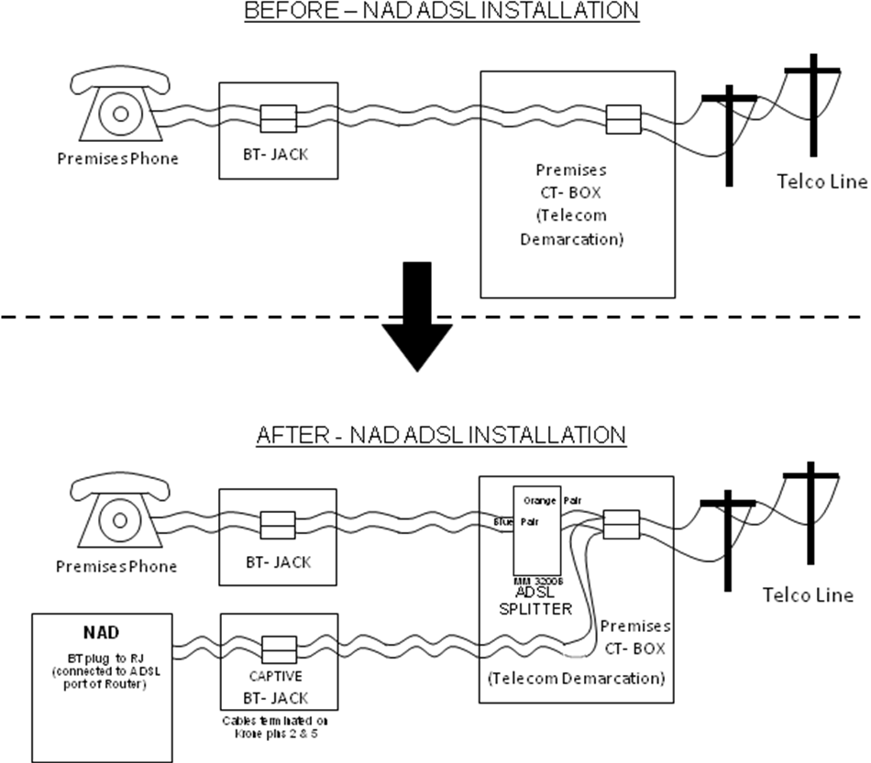

NAD 3G wireless Commissioning check-list

- NAD mounted in best signal location (near the Fire Alarm equipment )

- NAD secured to wall with appropriate fasteners

- Dedicated 230VAC feed – Switchboard, breaker, and location labelled at outlet.

- Batteries dated and initialled – connected observing correct polarity

- Connected SGD’s are being polled

- Signals are being received by Alarm New Zealand

- Connection documentation completed and returned to Alarm New Zealand

NAD ADSL Commissioning check-list

- ADSL Phone number of NAD ADSL line confirmed same as connection documentation

- NAD mounted near Telecom Demarcation point.( ADSL BT Jack installed)

- Captive BT jack-point upgraded on the Telco Demarcation point.

- ADSL splitter installed at Telco Demarcation as per ADSL wiring diagram

- NAD secured to wall with appropriate fasteners

- Dedicated 230VAC feed – Switchboard, breaker, and location labelled at outlet.

- Batteries dated and initialled – connected observing correct polarity

- Connected SGD’s are being polled

- Signals are being received by Alarm New Zealand

- Connection documentation completed and returned to Alarm New Zealand

